Extended Abstract Title
First name LAST NAME^{1,*}, First name LAST NAME ¹⁻² and First name LAST NAME ³
¹ Laboratory, Institution, City, Postal Code, Country
² Laboratory, Institution, City, Postal Code, Country
³ Laboratory, Institution, City, Postal Code, Country
*Corresponding author: identifiant@institution.com

Abstract
We kindly ask that all authors follow as possible these guidelines. Please make your paper looks like this template. The simplest way to do so is to replace its content with your own material. This template provides authors with most of the formatting specifications needed for preparing their extended abstract to be submitted preferably as a Word 97-2003 Document
- LIP Heading 1 (Bold, 10 pt)
Please submit your abstract electronically in a camera ready version to contact@lip-conference.org
  - LIP Headings 2 (Bold, 9 pt)
This template has been tailored for output on the A4 paper size (21 cm x 29.7 cm). Two pages and 1000 words are considered a minimum but please avoid to write more than four pages. You can use color figures for both the paper and online version.
The LIP2022 organizing committee will not do any real formatting of your paper. Thus, as already mentioned, your abstract should be “ready” but do not add page numbers.
The template is used to format your paper and style [1] the text (see LIP2014 proceedings to get an idea of the expected result). All margins, column widths, line spaces, and text fonts are prescribed. Please do not alter them. Use 9 points Palatino Linotype for your text (Body Text) with line spacing of exactly 12 pts. Footnotes are not allowed.
Complete content and organizational editing before formatting. Please take note of the following items when proofreading spelling and grammar:
  - Abbreviations and Acronyms
Define abbreviations and acronyms the first time they are used in the text. Abbreviations such as XRD, TEM or LMT do not have to be defined. Avoid using abbreviations in the title or heads.
  - Equations an symbols
Use preferably an equation editor like Mathtype (or word editor) to obtain right-numbered equations looking like Eq. (1):
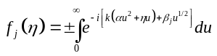
For Greek symbols and inline equations, like and 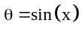, use also an equation editor. Matrices and vectors are in bold, e.g. and 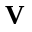
- Figures and Tables
Figure and table captions should be below the figures. Refer with “Figure. 1”, even at the beginning of a sentence.

Tab 1 | Tab 2 | Tab 3
X | Y | Z
X | Y | Z
Table 1 LIP Captions
- Acknowledgement
Please avoid the expression, “One of us (X. Y. Z.) thanks” Use instead “X. Y. Z. thanks…”.
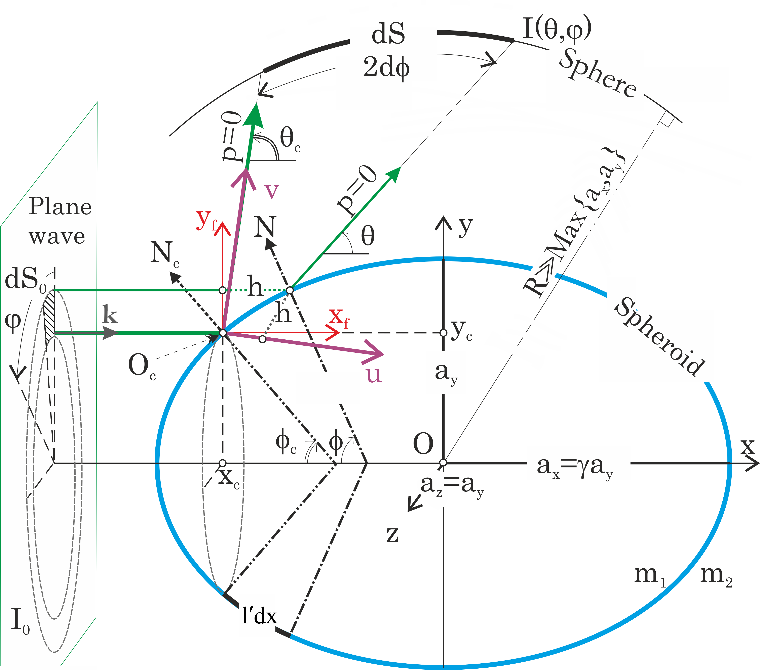
Figure 1 LIP Captions
- References
References are cited in the text by square brackets [1]. Please number citations consecutively within brackets. Two or more references at a time may be put in one set of brackets [1,2]. Refer to the reference number. The references are to be numbered in the order in which they are cited in the text. Do not use “Ref. [1]” or “reference [2]” except at the beginning of a sentence: “Reference [1] was the first . . .”
Unless there are five authors or more give all authors' names. To avoid the confusion between given name and surname use the format suggested below. Papers that have been accepted for publication should be cited as “in press”.
Use 8 points for references, and make the distinction between books [2], journals [3] and conference papers [4].
When submitting your extended abstract, please, compete and submit also the MS Excel form “FormMEx97_LIP2022.xls” (to be uploaded on the conference website) describing its promotors, contain and objectives.
- References
- Style: LIP references
- C.F. Bohren, and D.R. Huffman, Absorption and scattering of light by small particles (Wiley, New-York, 1983).
- Onofri F.R.A, Radev St. , Sentis M., Barbosa S., A physical-optics approximation of the near-critical-angle scattering by spheroidal bubbles, Optics Letters 37(22):4780-82 (2012)
- Barbosa S., Onofri F.R.A., Wozniak M., Touré O., Grisolia C., Optical characterization of highly ordered aggregates of colloidal nanobeads, Int. Conf. on Lasers and Interactions with Particles (LIP2012), paper 7.2, 26- 30 March., Rouen, France, 2012.

